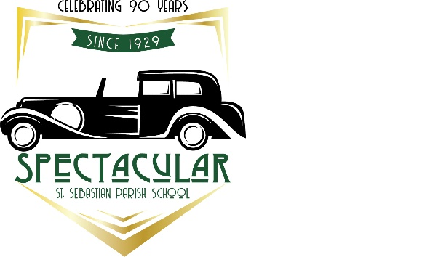
LIVE AUCTION PACKAGES
Reserved Front Pew for Christmas and Easter
VIP Wine Dinner for 6 at D’Agnese
Top Dog! - St. Sebastian VIP Parking Spot for a Year
Home in Chautauqua, New York for 15

Fine Dining and Wine by Vaccaro’s and an Art & Architecture Tour of our Parish with Father V.

Win a 65 inch Samsung UHD TV

A Four Night Napa Valley Trip for 6

Priest Feast with Fr. Anthony in the Rectory

World Class Cleveland Culture including Hamilton Tickets, a Mercedes-Benz Weekend Rental, an Overnight at the fabulous Ritz Carlton and more

Thirsty Dog “brew your own beer” Brew Session for 10, Akron Location

The Silent Auction includes Playhouse Square Theatre tickets, tuition vouchers, Indians and Cavs tickets, one of a kind classroom projects, a Weber grill, Cedar Point tickets, a Chez-Del decorative chest, dining certificates, exciting gift baskets and much much more!

