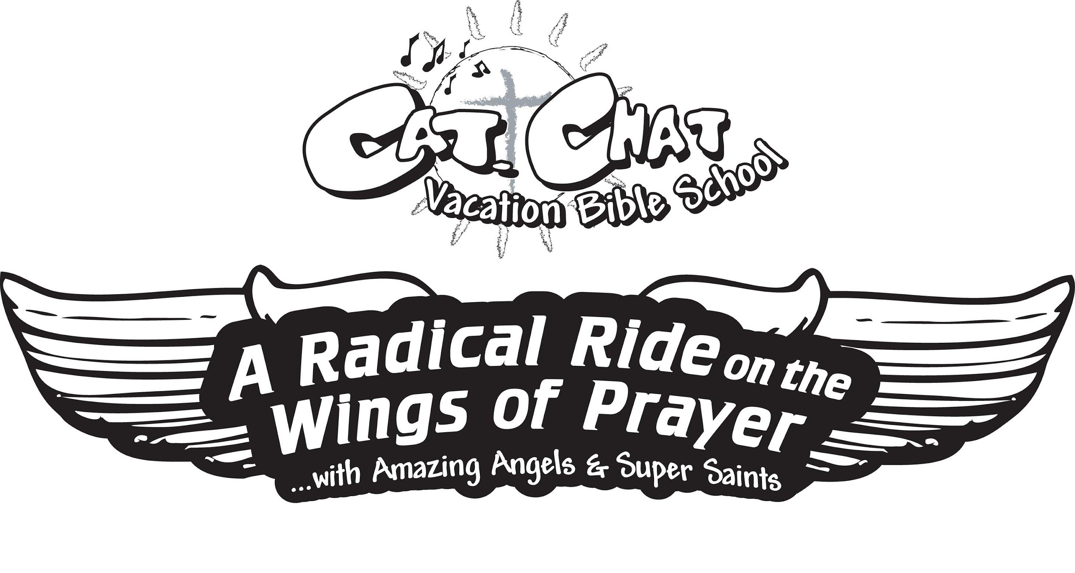
Vacation Bible School Participant Registration Form
Monday, July 25 - Friday, July 29, 2022 9:00-12:00
St. Sebastian Parish 476 Mull Avenue Akron, Ohio 44320 • 330-836-2233
Child’s Information:
Name: _________________________________________________________________________
Sex: (circle one) M F Age: ____________ Grade entering 2022/2023: _____________
Allergies or medical conditions: _____________________________________________________
Name: _________________________________________________________________________
Sex: (circle one) M F Age: ____________ Grade entering 2022/2023: _____________
Allergies or medical conditions: _____________________________________________________
Name: _________________________________________________________________________
Sex: (circle one) M F Age: ____________ Grade entering 2022/2023: _____________
Allergies or medical conditions: _____________________________________________________
Name: _________________________________________________________________________
Sex: (circle one) M F Age: ____________ Grade entering 2022/2023: _____________
Allergies or medical conditions: _____________________________________________________
Family Information:
Parents’/Guardians’ Name(s): _______________________________________________________
Address: _______________________________________________________________________
Home: ___________________ Work: ____________________ Cell: ______________________
Email: _________________________________ I am interested in volunteering for VBS ___yes ___no
Emergency Contact: Name: ______________________________________ Phone: _____________________
I understand that reasonable precautions will be taken to safeguard the health and well-being of the participants in this VBS and that I will be notified as soon as possible in the event of an emergency. In the case of sickness or an accident, I authorize and give consent to the VBS Team, or other associated volunteers of the VBS program to obtain medical care from a licensed physician, hospital, or medical clinic for my son/daughter in the event that myself or other legal guardian(s) cannot be reached. I hereby do release and forever discharge this Diocese, Parish and/or Organization from all manners of actions, claims which I or the child named above shall or may have for any reason, arising during my child’s attendance of the VBS.
Unless other written instruction is submitted, I also consent to allowing my child’s image to be recorded, either by photograph or video, and used during the VBS week or for future advertisement of Parish VBS programs. Any other use will require my further consent.

__________________________________ ______________
Parent / Guardian Signature Date

Return completed form and check by July 15, 2022 to St. Sebastian Parish Rectory Attn: VBS 476 Mull Avenue Akron, Ohio 44320. Children of volunteers attend for free; otherwise cost is $10 for the first child and $5 for each additional child.

