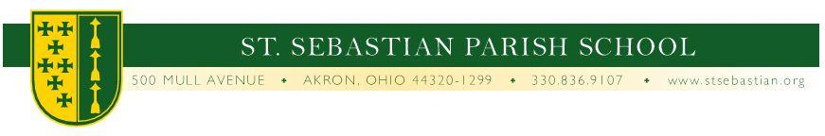
PERMISSION TO RELEASE SCHOOL RECORDS

By my signature below, I as the parent or legal guardian of ______________________________
whose date of birth is _____________________, give permission to the principal of the following school, _________________________________ to release the school records to St. Sebastian Parish School. Please send all records including: grades, academic records, psychological assessments and records, disciplinary records attendance records, medical reports and testing results and/or evaluations.

Please mail or fax records to:

St. Sebastian Parish School
500 Mull Avenue
Akron, OH 44320
Phone-(330)836-9107
Fax-(330)836-7690

X___________________________
Parent/legal guardian

X___________________________
Date

