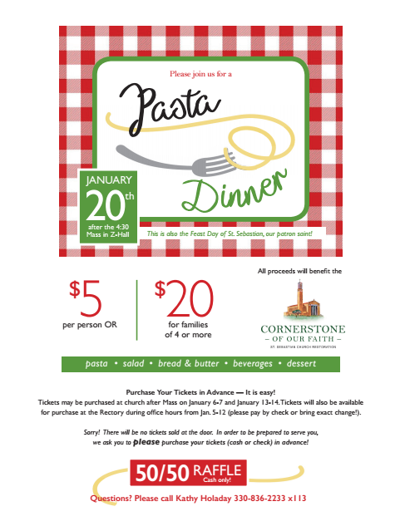

**Purchase Your Tickets in Advance 🡪 It is easy!**

Tickets may be purchased at church after mass on January 8 and 9.

Tickets will also be available for purchase at the Rectory

during office hours starting on January 5-13.

**Questions? Please call Marcy Smith 330-836-5624 or chefms68@aol.com**

Sorry! There will be no tickets sold at the door.

In order to be prepared to serve you, we ask you to **please**

purchase your tickets (cash or check) in advance!

**Tickets on Sale in the back of the Church after mass on Saturday and Sunday, January 8 and 9 or in the Rectory Office!**

**January**

**15th**

**in Z-Hall**

**after the 4:30 Mass**

**Please join us for a Parish**