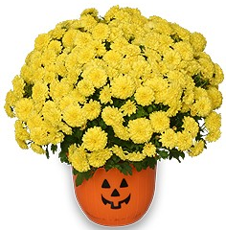
Mum Sale Fundraiser St. Sebastian Class of 2022 Support our Washington, D.C. trip May 4-6, 2022

Order Form Due Date: Friday, September 10, 2021
Pickup Date: Saturday, September 18, 2021, 9am-12pm
Pick up Location: Byrider Hall (gymnasium)

**Each 8th grade student must sell at LEAST 2 mums**

**CHECKS MADE PAYABLE TO ST. SEBASTIAN SCHOOL (NO CASH PLEASE)**

Cut below the line and send in with check payable to St. Sebastian School. Envelopes can be addressed to Brenda Mahaney (Grace) via backpack express at school. Customers can also mail order forms and payment to Brenda Mahaney, 311 Mineola Ave., Akron, OH 44313.

Questions? Please text/call Brenda Mahaney 330-604-7935 or Alice Incorvia 330-990-5630

Your student’s name / 8th Grade Student’s name you are supporting (if applicable):

Your Name:
Cell Phone:
Email:

*** All mums are 8 inches and are annuals. ***
Customer Name/Cell Phone # | Red | White | Yellow | Pink | Orange | TOTAL QTY | Cost Each | TOTAL  COST
 |  |  |  |  |  |  | $7
 |  |  |  |  |  |  | $7
 |  |  |  |  |  |  | $7
 |  |  |  |  |  |  | $7
 |  |  |  |  |  |  | Total Amount Due | $

Questions? Please contact Brenda Mahaney 330-604-7935 or Alice Incorvia 330-990-5630

