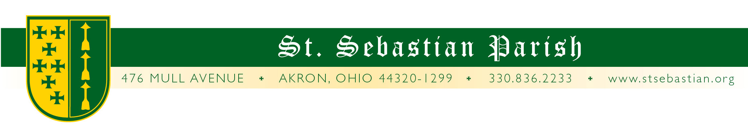
Angelus Letter
13 May 2021
Our Lady of Fatima
LETTER #119
Dear Parish Family,

WHAT YOU NEED TO KNOW FOR THIS WEEKEND

Friday Mass at 8AM* with Fr. Simone
Friday Confessions at 4PM*

Saturday Mass at 8AM* with Fr. Valencheck
Saturday Confessions at 9:30AM*
Saturday Mass at 4:30PM* with Fr. Simone

Sunday Mass at 9AM* with Fr. Valencheck
Sunday Mass at 11AM* with Fr. Simone
Sunday Mass at 1PM* with Fr. Paschal OSB

* Masks are required.

ATTENTION PARENTS OF INFANTS!

The College America 529 investment plan has been expanded to assist parents to pay for K-12 private school tuition. 529 plans typically offer you unsurpassed tax breaks. Earnings in a 529 plan grow tax-free and are not taxed when they're withdrawn. This means that however much your money grows in a 529, you'll never have to pay taxes on it.

Ease the burden on your future self and help ensure a quality, safe, Kindergarten through college Catholic education for your children. For more information, check out the plan site or speak with your investment professional. https://www.collegeadvantage.com

SPEAKING OF SAVINGS

When I was first named pastor (well, administrator) of St. Sebastian Parish and Fr. Pfeiffer was here, the parish had to write a check each year, for $11,000 per priest to go into the priest pension fund. This is separate from the diocesan pension fund and it was a large commitment. Then we had the Rooted in Faith Campaign, some of the funds of which went toward more fully funding the pension fund which in turn helped to reduce the annual parish liability. Currently we are in the Heart of a Shepherd Campaign (which you will be hearing more about) and if successful, it will fund the priest pensions to such a degree that the parish will only have to issue a check for $1,000 per year, per priest for the pension fund. That means if there are two priests in residence at St. Sebastian Parish, $20,000 remains at the parish every year! Now that is good news!

NEW SEMINARIAN!

I just received an email that Mr. Joshua Bliss, who was brought into the Church a couple of years ago at St. Sebastian Parish, has just been excepted to the seminary for the Institute of Christ the King! Congratulations Joshua! Please keep him, our seminarians and those contemplating the religious life in your prayers.

ORDINATION!

When this was being typed on Tuesday, the priestly ordination Mass for our diocese was exactly four days and fifty-five minutes away! Once again, this year, attendance is reduced, but if you would like to watch, it will be live-streamed. Go here: www.dioceseofcleveland.org/events/2021/05/15/ordination-of-priests.

RETURNING TO NORMAL?

Recently Bishop Malesic was visiting and we were talking about the process of parishes returning to normal worship and it seems he envisions that day coming. One of the many hurdles that needs to be tackled before the obligation to return to Mass is reinstated is that the requirement for social distancing would need to be abrogated. “If I am going to reinstate the obligation to attend Mass,” he said, “then if people show up, we have to take them in no matter how many people are already there.”

As a “first stab” in preparing the diocese to return to a more normal state, the diocese put together this short video. It may not appear to say much, but like trying to turn an ocean liner, the process in executing the turn is cumbersome and lengthy. It may not seem like much at first, but like buds on a tree, it is the beginning of the first signs! To see the video, go here:
https://www.dioceseofcleveland.org/news/2021/05/06/watch-hope-is-on-the-horizon

ABBOT CLEMENT ZELESNIK OSB

Every weekend we get help from the Benedictine, St. Andrew Abbey when they come to St. Sebastian parish to celebrate the1:00PM Extraordinary Form Mass with us. The retired abbot, Abbot Clement, passed away recently. Our condolences are extended to all of the monks and those living in the monastic order located in Cleveland.

THANK YOU FOR YOUR GENEROSITY

TO GIVE TO THE PARISH: https://www.stsebastian.org/donate
TO GIVE TO THE FOUNDATION: https://www.stsebastian.org/foundation/donate

PRAYERS FOR THE SICK

Please keep all of our sick and distressed in your prayers:

Annette Bailey, Brenda Boville, Karen Brugmann, Megan Brugmann, Jill Buffa, Regina Buhalak, Dan Canale, Christopher Casey, Emilio Cheuy, Rita Cummings, Anthony D’Attoma, Vince and Jackie DelMedico, Marjorie DeLuca, James Fanning, Rita Buhalak Gossford, Robert Hickey, Phil Hochstetler, Ann Hubiak, Carolyn Jeske, Kimberly Jesser, Kathy Johnson, Jean Labate, Myrna Marple, Don Matis, Betty O’Hara, Keith Pecek, Sue Prexta, Robert Rader, Mary Ricks, Nancy Ropchock, Aaron Salisbury, Ellie Salisbury, Ann Sandvick, John Schultz, Cory Schulz, Kathy Seikel, Brian Walsh and Steve Watral.

God bless you,

Fr. Valencheck.
St. Sebastian, pray for us.
St. Mary, pray for us.

