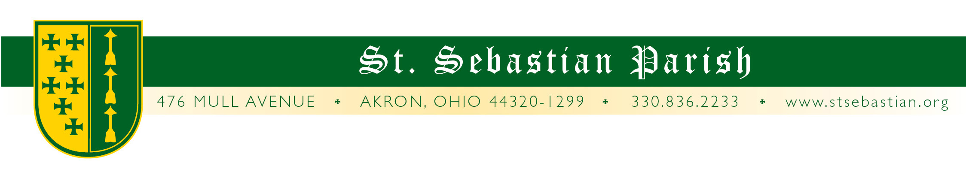
Angelus Letter
10 September 2020
Thursday of the Twenty-Third Week in Ordinary Time

Dear Parish Family,

WHAT YOU NEED TO KNOW FOR THIS WEEKEND

Friday Mass 8AM* Fr. Valencheck
Confessions 4 to 5PM*
Saturday Mass 8AM* Fr. Simone
Confessions 9:30 to 10AM*
Vigil Mass 4:30** Fr. Valencheck
Sunday Mass 9AM* Fr. Simone
Mass 11AM* † Fr. Valencheck
Mass 1PM* Fr. Bede OSB

* Masks are required.

**At the 4:30 Mass, with permission from the diocese, there is an absolute requirement for masks to be worn.

† Our Annual Eucharistic Devotions following this Mass.



Annual Eucharistic Devotions
If you have never been in our church in the middle of the night, here is your chance to do so while giving thanks and praise to Jesus, the center, cause and focus of our community. He will be exposed on our altar following the 11AM Mass this Sunday and will remain on our altar day and night until closing ceremonies at 8PM on Tuesday evening.

THANK YOU for adopting hours. As of Thursday morning, there are only a few hours not covered:
2PM Monday
Midnight Monday
1AM Tuesday
2PM Tuesday
And, as always, if you cannot take a whole hour or a specific hour, even if you only have a few minutes, please stop in and greet Him on this exceptional time at our parish.

SCHEDULE OF EVENTS:
Sunday, September 13th
11AM Mass Opening ceremonies
1PM Mass
4:30PM Vespers (Evening Prayer)
8PM Compline (Vespers)
Monday, September 14th
8AM Mass
11AM Funeral
4:30PM Vespers
8PM Compline
Tuesday, September 15th
8AM Mass
4:30 Vespers
7 to 7:30PM Confessions
8PM Compline, Candlelight Procession, * Benediction.

* The procession will be around the St. Sebastian block with candles. The St. Sebastian painting will also be in the procession to ask for his intercession for protection against pandemic and sickness. The procession portion of this evening is weather dependent.

PADRE PIO

PLEASE NOTE: Somewhere I wrote incorrectly that the Mass at which we would introduce the Padre Pio relic would be at the 11AM Mass. This is incorrect. It will be at the 9AM Mass next Sunday, September 20th. Fr. G. David Bline will be the main celebrant.

A relic consists of the physical remains of a saint or the personal effects of the saint preserved for the purposes of veneration as a tangible memorial. If you think about it, this is not so strange. I have a lock of hair from my dog Sebastian. You might treasure a guitar played by the Beetles. I once went to an Engelbert Humperdinck concert (don’t ask) and at one point they brought out a whole stack of red, silk handkerchiefs. He would wipe his forehead or something and throw it the audience who, interestingly enough, fought over them. We like to have some tangible connection to a person we admire.

So, it is with the saints. In this particular case, we have a tiny piece of a glove that St. Padre Pio wore which is stained with blood from his stigmata. Its purpose is to draw us into prayer and contemplation, leading us closer to God.

By the way, Catholic altars typically have relics in or under them keeping with the ancient tradition of having altars built over the graves of the saints and martyrs. The saints in our altar are from Saint Donatus (martyred under Diocletian) and St Pope St Innocent I.

OUR NEW BISHOP

Bishop Malesic will be installed as the 12th Bishop of the Diocese of Cleveland on Monday, September 14, 2020 at 2pm. Due to COVID restrictions, the installation is a ticketed event. They are only able to invite 140 people in the Cathedral. You can participate online at www.dioceseofcleveland.org and follow the instructions provided on the diocesan website. Please keep Bishop Malesic in your prayers as he undertakes his new role as our Bishop.

HAPPY BIRTHDAY DEACON TERRY PEACOCK!

Today is Deacon Terry’s birthday! He is still coping with some health issues but hopes to be back in our sanctuary in the future. Please say a prayer for him! We miss you being here Deacon Terry.

MISC.

“AMEN!” Masks have made me aware that my hearing is not as good as it used to be. Masks do make it more difficult to hear - especially those of you who are soft spoken. Our Extraordinary Ministers of Holy Communion have asked me to ask those of you who are soft spoken and attend the ordinary form of the Mass to please say “Amen” a little louder. (“Amen” is not said by the communicant at the extraordinary form of the Mass.)

MISSALETTES AVAILABLE: Missalettes are available in the narthex of the church. If you would like one to take home, please take it. Since they will be obsolete in a couple of months, Lynn thought you could at least get some use from them at home. You could bring them to Mass if you wish but please take them with you when you leave! (Is this not ironic that we have to do this after we finally have missalette holders in our pews? Ha!)

  SCHOOL GARDEN
  I thought these pictures taken with a drone from the school science department were pretty cool. The first is of our students preparing the garden as part of their STEM education. The second is what it looks like at the peak of the growing season. On Wednesday, another 70 pounds of food was harvested and distributed to those in need through the Good Samaritan Center. Great job students & gardeners!
  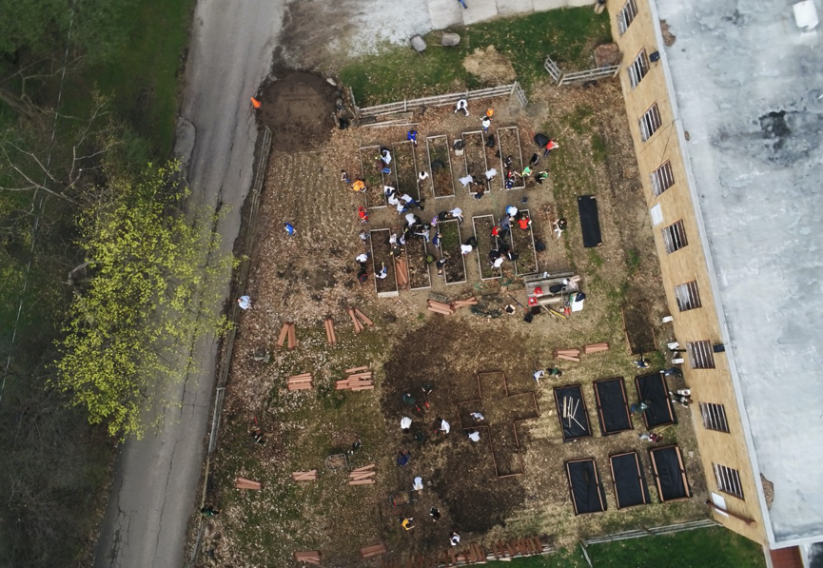

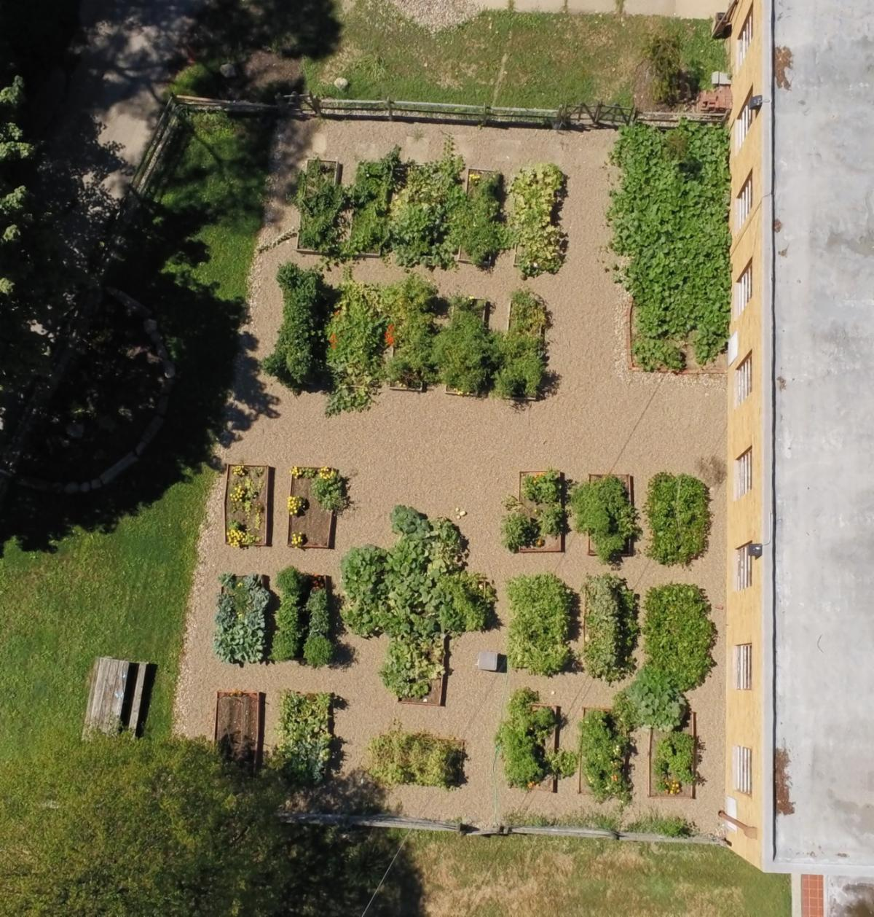

PRAYERS FOR THE SICK

Please keep all of our sick and distressed in your prayers:

The Caufield Family, Regina Buhalak, Paul Carr, Elizabeth Clark, Rita Cummings, Anthony D’Attoma, Gretchen & Steve Golnar, Carolyn Jeske, Kimberly Jesser, Kathy Johnson, Chuck Kastor, Stan Kennedy, Jean Labate, Don Matis, Betty O’Hara. Pamela Oliver, Terry Peacock, Keith Pecek, Sue Prexta, Frank and Nancy Ropchock, Nancy Rosche, John Schultz, Cory Schulz, Marilyn Spallino, & Marie White.

God bless you,
Fr. Valencheck
St. Sebastian, pray for us.

