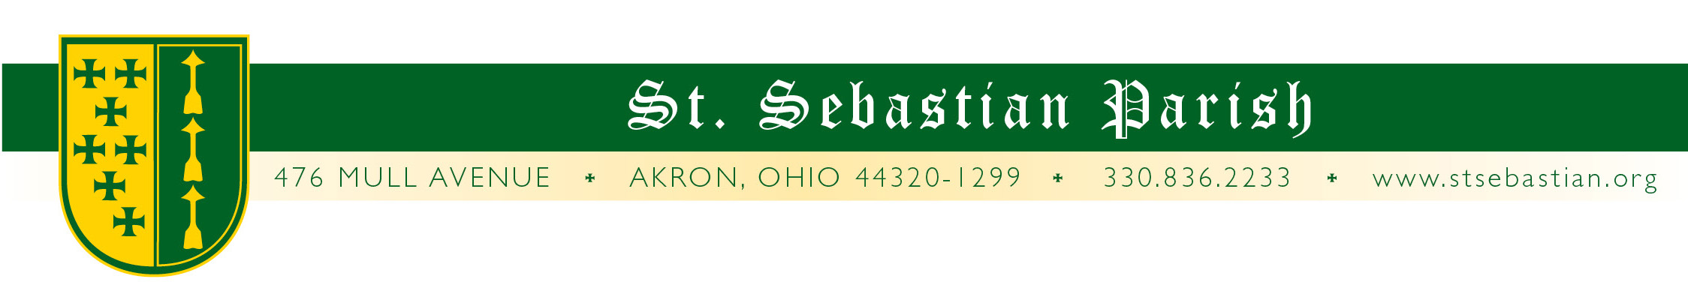
Angelus Letter
8 June 2020
Monday of the Tenth Week in Ordinary Time

Dear Parish Family,

Just in case you were unaware, we are now permitted to have baptisms and funeral liturgies. There are some restrictions but for the most part, we are a go.

As far as other offerings from the parish, there are all kinds of different levels of caution taking place. Hospitals and nursing homes are not united in their stance on visitors for anointing and Communion. One of our nursing homes had a change in policy mid-last week allowing Fr. Simone to celebrate the Anointing of the Sick with a person who later died.

Churches in general are not on the same page. Not even all Catholic parishes. For varied reasons and reasonings, some have not even opened their doors for prayer yet. Others have mostly abandoned the guidelines. By my reckoning we, at St. Sebastian Parish are somewhere in the middle.

There have been no new guidelines from the diocese for quite some time. (For a spell. emails were arriving so quickly we didn’t have time to read one before the next one was sitting in the inbox!) As we slowly return to some semblance of normality and more of you are involved, we have to plan further out, directives or no. So, here is a rough idea of what to expect this week, which I do not expect will change even if there are new directives:

- We will maintain our current Mass schedule
- Until school returns, Thursday Mass will remain at 8AM.
- Confession this week will be on Friday from 4 to 5PM and Saturday from 9:30 to 10AM.
- There will be a Holy Hour, Compline and Benediction Tuesday from 7 to 8PM.
- The 11:00 Sunday Mass will be in the school courtyard weather permitting. (My phone says the weather will be perfect and so far it has been perfectly wrong so I am nervous about what that bodes.) Please remember to bring a chair.

We have a staff meeting this coming Thursday to continue discussing our preparedness plan. In Friday’s Angelus letter, there should be additional news to share about the foreseeable future.

REPORT FROM THE WEEKEND

Things appear to be going well thus far. The attendance at 4:30 Mass is the lowest of the weekend Masses, so if you are looking for a Mass with fewer people, this may be the one for you. The 11AM outdoor Mass grew from the previous week. Being able to spread out, not wear masks and having an easier time remaining socially distanced going to Communion are sited for reasons people attend this Mass. Fortunately, it is not too hot nor do we have many bugs to contend with yet. 9AM was by far the most crowded with some having to stand due to the reduced pew space. The 1PM Mass had almost normal pre-COVID numbers.

CORPUS CHRISTI

Next weekend is Corpus Christi weekend! There will be a Eucharistic procession following the 9AM Mass weather permitting. At the end of the Mass, you will be invited to follow the Eucharist around our property (socially distanced of course), giving thanks for all the protection we have received during the pandemic and asking for His Blessing, ending at the location of the 11AM Mass where there will be benediction. I hope to have a bevy of seminarians to assist us with these celebrations and events.

Dear Altar Servers,

I truly do miss you assisting at the altar and so does Fr. Simone. Not lightly do I tell you that very often, visiting clergy comment on how competent and well comported are our servers! It is my desire to have you back at your ministry soon. Thank you for all that you do for the glory of God and good of the community.

I ask the community to say a prayer for our servers and that they are able to return to their duties soon!

THANK YOU!

Thank you to the awesome people who stick around after the 9AM Mass to sanitize the church! You are awesome!

PRAYERS FOR THE SICK

Please keep all of our sick and distressed in your prayers:

The Caufield Family, Elizabeth Clark, Rita Cummings, Anthony D’Attoma, Gretchen & Steve Golnar, Carolyn Jeske, Kimberly Jesser, Stan Kennedy, Jean Labate, Don Matis, Mary Kay McCarron, Pamela Oliver, Keith Pecek, Sue Prexta, Frank and Nancy Ropchock, John Schultz, Marilyn Spallino, Ron Tedeschi, & Marie White.

God bless you,

Fr. Valencheck.
St. Sebastian, pray for us.
Holy Mother, pray for us.

