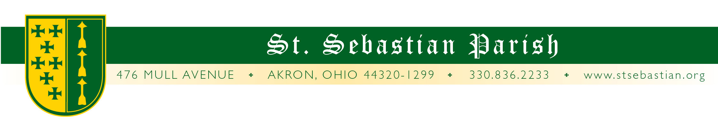
Angelus Letter
25 November 2020
Wednesday of the Thirty-fourth Week in Ordinary Time
St. Catherine of Alexandria

Dear Parish Family,

WHAT YOU NEED TO KNOW FOR THIS WEEKEND:

Thursday Mass at 9:00AM* with Fr. Rosing - Pastor of Holy Family, Stow

Ecumenical Service Cancelled

Friday Mass at 8AM* with Fr. Bearer - Parochial Vicar at St. Francis de Sales

Friday Confessions - Cancelled

Saturday Mass at 8AM* with Fr. Merzweiler - Pastor of St. Frances de Sales

Saturday Confessions Cancelled

Saturday Vigil Mass at 4:30* with Fr. Bline - St. Mary Seminary

Sunday Mass at 9AM* with Fr. Bline

Sunday Mass at 11AM* with Fr. Bline

Sunday Mass at 1PM* with Fr. Paschal OSB

* The Diocese of Cleveland along with the bishops of the state of Ohio have issued an absolute requirement for the wearing of masks at all Masses without exception.

THE LATEST NEWS

Firstly, a report on Fr. Simone. He had a test on Tuesday and it came back negative for COVID. This is both good news and challenging news. It is good in that he does not have COVID nor would he have spread it around. The challenging news, in a strange twist of irony, is that since we were together, he has to keep distant from people for a week longer than I do in order to make sure that he does not come down with anything! I, on the other hand, will be released back into the wild Sunday evening (I’ll wait until Monday) and, according to health officials, will be of no risk to anybody nor will anybody be of risk to me for approximately 12 weeks. This is dependent upon me being symptom free through Sunday, which so far . . . so good.

It has been an interesting experience keeping to my rooms. On the one hand, there is a burst of energy to get things accomplished. So, my Christmas shopping is complete, I’ve gone through all my files, cleaned my room . . . On the other hand, It is business as usual in the rectory and I still receive tons of emails and texts and mostly need to respond, “I can’t assist you at the moment but trust you to do well.”

We have been so blessed by our neighboring priests who have come in to assist us while we have been unable to serve the parish due to this Covid situation. They come from busy places and we are so fortunate that they were even available. We could have easily been in the position to have had to close our doors and dispersed to other parishes for a week. In fact, I was supposed to be helping out at St. Paul Parish for the same reason that we need priests here, but was taken off of that list for obvious reasons. So please keep all these priests in your prayers.

Thank you to everybody who is pulling extra weight to keep the parish plugging along, for those who are extending extra patience and understanding, and for all who remember the parish in prayers. As I celebrate Mass in my room these next few days, I will be remembering all of you.

“#weGiveCatholic.”

The St. Sebastian Parish Foundation is pleased to support the global effort of Giving Tuesday as we kickoff this season of giving in a concentrated “Catholic” effort sponsored by the Catholic Community Foundation in the format of “#weGiveCatholic.”

This online day of Catholic Giving in Northeast Ohio is taking place on
December 1st - the biggest online giving day of the year, #GivingTuesday.

The St. Sebastian Parish 2020 #weGiveCatholic project … “Chalk the Walk” will bring attention to the need to restore and repair the beautiful sandstone walkways around our school and rectory. https://www.wegivecatholic.org/

Please support our #weGiveCatholic project this year on December 1, 2020. Follow this link and support St. Sebastian Parish School and the “Chalk the Walk” project to restore and repair the beautiful sandstone walkways around our school and rectory. Visit https://www.wegivecatholic.org/ to donate.

PRAYERS FOR THE SICK

Please keep all of our sick and distressed in your prayers:

Please keep all of our sick and distressed in your prayers: The Caufield Family, Regina Buhalak, Rita Buhalak Gossford, Emilio Cheuy, Barbara Crawford, Rita Cummings, Anthony D’Attoma, Carolyn Jeske, Kimberly Jesser, Kathy Johnson, Chuck Kastor, Stan Kennedy, Jean Labate, Don Matis, Betty O’Hara. Pamela Oliver, Our Lady of the Elms Convent, Keith Pecek, Sue Prexta, Logan Rice, Frank and Nancy Ropchock, Ellie Salisbury, John Schultz, Cory Schulz and Marilyn Spallino.

God bless you,

Fr. Valencheck.
St. Sebastian, pray for us.
Holy Mother, pray for us.
St. Catherine, pray for us.

