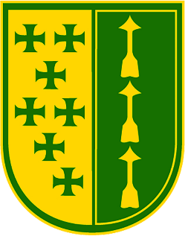
St. Sebastian Parish Council
Meeting Minutes
12/13/2021

In Attendance: Father Valencheck, Ivan, Tracie, Marcy, JIm, Christina, Alex, Susan, Sue, Ed, Natalie, Dave, and Jennie

Excused:

Time Began: 6:00 p.m.
Adjourned: 8:30 p.m.
Welcome
- Christina opened the meeting and introduced guests: Kathy Holaday and Ken Contrera from St. Sebastian and Jamie Heinl from Holy Family
- Opening prayer was led by Sue Sassano

Pastor’s Report - Fr. Valencheck
- None given

Old Business
- Nothing discussed this month

New Business
- Guest Speaker- Jamie Heinl Director of Stewardship and Ministry Engagement at Holy Family in Stow gave a brief presentation on how Holy Family operates as a stewardship parish. She answered questions about her role and responsibilities, how the stewardship program was created, current challenges, and what she envisions for the future.
- The Parish Council celebrated Christmas with a delicious meal prepared by Marcy.
- A Parish Council group photo was taken.

Pulse of the Parish/Commission Reports

Compline –
Next Meeting: January 27, 2022 at 7:00 p.m
Prayer and Compline – Ivan

