The Sanctuary Society invites all women of St. Sebastian Parish & School to our annual Christmas Tea

Wednesday, December 8, 2021
6:30-8:30 pm in Zwisler Hall

- Please bring a dozen cookies or your favorite holiday desert to share. Goodies can be delivered to Zwisler hall 1-4 pm.

- Performances and Entertainment provided by St. Sebastian’s very own band

- Raffle Basket tickets will be sold for a $1 each or 5 for $5

- Opportunity to pay $20 Membership Dues

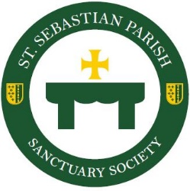
RSVP deadline is November 29th by completing the form below and return to the rectory or school office in an envelope marked “Christmas Tea” to the attention of Wendy Burgoyne.

Sanctuary Society Christmas Tea 2021

*Your Name___________________________________________ number in party____________
**I would like to be seated with
____________________________________ ____________________________________

____________________________________ ____________________________________
*Anyone attending must complete the form. Tickets and seating assignments will be given out upon arrival.
**Please note all tables seat 8 people and we will do our best to accommodate the request you noted.

