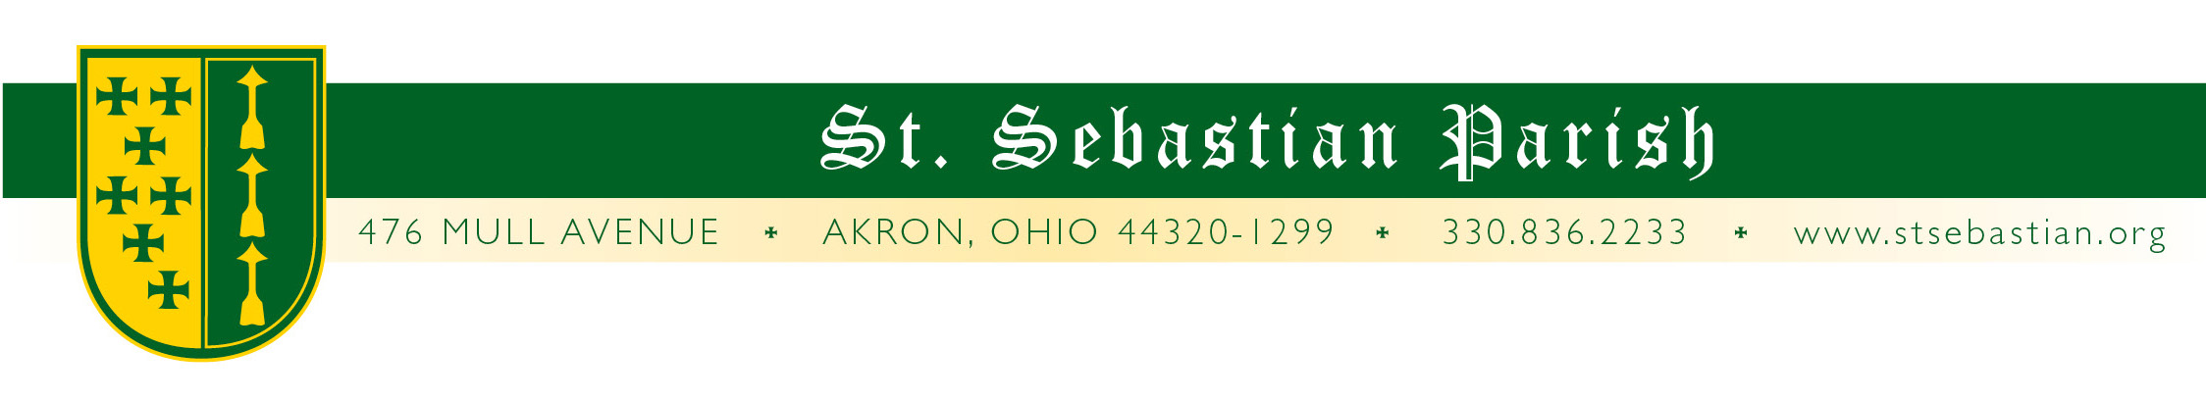

Dear Parents,

I pray that you are having an enjoyable summer! I would like to welcome our new and returning students to the St. Sebastian Parish School of Religion (PSR). My name is Cinnamon Chivers and I am the PSR Principal. I am honored and quite excited to be a part of this spiritual journey with you and your children. I look forward to getting to know each of our PSR families throughout the year.

The PSR program meets on Sunday mornings in the St. Sebastian Parish School building from 9:30 a.m. until 10:45 a.m. Students enrolled in the program are expected to have good attendance and participate fully in all PSR activities. There is much for your children to learn about their faith and their presence is key to building their spiritual foundation.

Registration can be completed by printing and filling out the online form and returning it to the parish office with your tuition payment. You may drop it at the rectory or mail it. To find the form, please visit the PSR page at stsebastian.org under the Faith Formation tab. Documents to be completed and returned for each child are as follows:

- Parish School of Religion Registration Form
- Sacramental Certification as indicated on registration form if not baptized at St. Sebastian
- A check made payable to St. Sebastian Parish (online payments are not available)

The first day of class AND Open House is on Sunday, September 13th from 9:30-10:45. At the Open House, you will have the opportunity to view your child’s classroom and meet the PSR staff. After class, many of our families continue to model our faith by attending the 11:00 Sunday liturgy to receive the sacraments with their children.

Communication in our school takes place primarily via email. A school calendar is available on the website or can be picked up in the office once PSR begins. Parents with students receiving their First Communion or Confirmation this year will receive separate communications with more information.

If you or someone you know has interest in being an integral part of the instruction that takes place in PSR, please let me know. At this time, we are in need of volunteer Catechists / PSR Teachers in our classrooms. This is an opportunity to share your faith with children as you disciple them in the ways of our faith. Easy to use materials are provided. Virtus training is a valuable requirement that allows you to participate and volunteer in all children’s activities at St. Sebastian. We are all called to discipleship in the church and I promise you a special kind of joy that comes from sharing your faith and teaching children. It also has a remarkable impact on your own children to see you taking part and sharing your faith with their peers. Please spread the word to others about this need and let me know if you would consider filling one of these openings.

I am pleased to take part in the St. Sebastian PSR program and look forward to working with you and your children in the upcoming year.

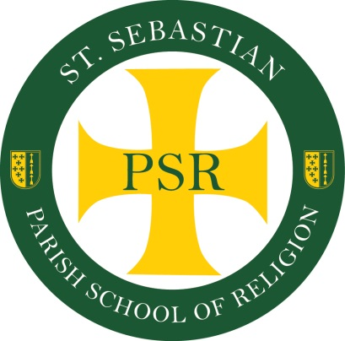
Peace of Christ,

Cinnamon Chivers
Parish School of Religion, Principal
330-836-2233 ext: 136
psr@stsebastian.org

