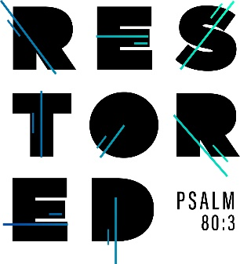

2020 Steubenville Youth Conference
Where: Franciscan University of Steubenville
When: June 19-21, 2020
Cost: 218.00 - Cost includes registration, meals, housing, T-shirts and transportation. (We will do some fundraisers to help reduce the price.)
Who can go: Any student who will be in high school next school year
(2020-2021) and 2020 graduates

Come join us as our Youth Ministry travels to the Franciscan University of Steubenville to worship God with thousands of other teens! We will stay in the campus dorms and enjoy a weekend listening to amazing witnesses, inspiring music, participating in great liturgies and experiencing our faith like never before!! Father Anthony Simone will be joining us this year on our faith journey!!
Don’t miss out on this incredible opportunity!

Please turn in the form below and the $40.00 check or cash deposit into the
St. Sebastian Parish Office marked with my name on it.

For additional information contact Keith Johnson at:
johnsonk@stsebastian.org
----------------------------------------------------------------------------------------------------------------------------------
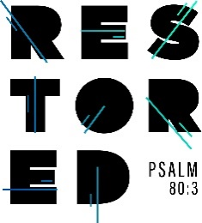 2020 Summer Youth Conference

Name: __________________________ Phone: _________________________

Address: _________________________________________________

Parent Email Address: ____________________ T-shirt size: Adult S M L XL XXL

Grade in 2020-2021 school year: ______________ DOB: _____________________

Please include $40.00 deposit (check __ cash __)
Please make checks out to St. Sebastian Parish

