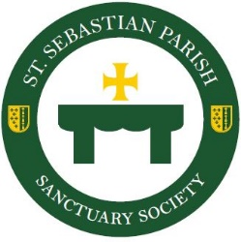
Sanctuary Society Annual Dues $20

Did you know all women of St. Sebastian Parish are members of Sanctuary Society? Since 1928, Sanctuary Society maintains our altar with candles, wine, hosts and flowers. Please continue supporting our mission by submitting your $20 membership.

Sanctuary Society is blessed to announce the 2020-2021 board members
President- Ana Borges VP – Diane Haller
2nd Vice President - Eva Reyes Treasurer- Mary Kinkelaar
Corresponding Secretary – Wendy Burgoyne Recording Secretary – Lori Oakes

We have all faced many obstacles during the Covid-19 Pandemic, including cancelled events and social distancing. Due to the current restrictions and safety guidelines, the 2020 Christmas Tea is cancelled. We are remaining hopeful that in the spring we can come safely together to enjoy the popular International Festival. We will keep you apprised of the new date as it gets closer.

Sanctuary Society financially supports the needs of the parish and we are asking that you help with this tradition by completing and returning the form to the rectory.
----------------------------------------------------------------------------------------------------------
Sanctuary Society 2020/21 Membership $20

Name_______________________________________________________________________

I would be happy to volunteer my time, talent and support with Sanctuary Society.
Please contact me at the following:

Phone______________________________ Email_____________________________________

