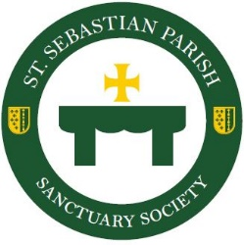
Sanctuary Society 2020
Christmas
Memorials

The Beauty and Love of Those Close to Your Heart
Will Glorify Our Altar for Christmas

Deadline: Monday, December 21st
Donation: $10 per Memorial

Your gift may be mailed or dropped off to the Rectory,
Attention: Sanctuary Society
476 Mull Avenue • Akron, Ohio 44320

Forms must be received by December 21st to publish names of honorees/memorials in the parish bulletin. Donations received after December 21st will be accepted, but publishing of honoree/memorial names cannot be guaranteed.

Sanctuary Society 2020 Christmas Memorial Donor Information

Name_________________________________________________________________________

Address_______________________________________________________________________

Phone_________________________________________________________________________

Please accept my donation in honor/memory of:

Name___________________________________________________ Donation $___________

Name___________________________________________________ Donation $___________

Name___________________________________________________ Donation $___________

Name___________________________________________________ Donation $___________

Name___________________________________________________ Donation $___________

Name___________________________________________________ Donation $___________

Total $ ___________

