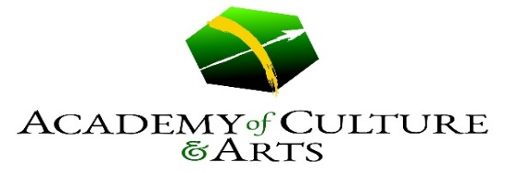
@ St. Sebastian Parish
Fall Course offerings, 2019

Classes for all ages:
Piano Lessons-Jeff Beshore- email: jbeshore@aol.com
Violin Lessons-Sarah Husak - email: shusakviolin@gmail.com
Guitar Lessons- George Bachmann-email: geobach3@gmail.com
Voice Lessons-Merrisa Coleman- email: merrisa.coleman@gmail.com
Parent/Child Group Guitar Lessons -George Bachmann-email: geobach3@gmail.com
Classes for Adults
Steel Drum Band for Adults --Ron Martin-email: martinr@hoban.org
Intro to Digital Photography*NEW*—Joan Crookston-email: joanemily@live.com
Chamber Music Ensembles --Sarah Husak –email: shusakviolin@gmail.com
Classes for kids
Jazz/HipHop Dance—Shenna Mason-email: platinummovements@gmail.com
Ballet-Modern Dance- Kim Lucas-email: Kfitlucas@hotmail.com
TigerKids Kung Fu – Adam Boyer- email: victorydefense@icloud.com
Band Instrument Lessons – Scott Mason – email: masonmusic2@gmail.com
Intro to Digital Photography for Teens *NEW* – Joan Crookston – email – joanemily@live.com
CONTACT OUR TEACHERS for scheduling information and TO REGISTER FOR CLASSES
Visit our website for more information:
stsebastian.org/academy
Classes begin week of September 9, 2019-new students always welcome

@ St. Sebastian Parish

www.sebastianarts.org

Hello, Parents:
The Academy of Culture and Arts at St. Sebastian Parish is proud to present our Fall Session Course Offerings, 2019!
Please take a look at the back of this letter for a listing of our exciting arts engagement offerings in Visual Arts, Sculpture, Dance and Music. We will also continue to offer private lessons on Piano, Violin, Band Instruments and Guitar as well as Voice for individual instruction and group vocal instruction for kids through Akron’s Own “The Young Singers Companye” vocal organization. Also offered are the Introduction to Digital Photography Classes on Saturday mornings, Parent/Child group guitar classes, and our first-ever St. Sebastian Parish Steel Drum Band!
Of particular interest for the students at St. Sebastian are:
Piano Lessons- Jeff Beshore-email: beshorej@stsebastian.org
Jazz/HipHop Dance—Shenna Mason-email: platinummovements@gmail.com
Ballet Modern Dance—Kim Lucas- email: Kfitlucas@hotmail.com
TigerKids Kung Fu – Adam Boyer- email: victorydefense@icloud.com
Band Instrument Lessons – Scott Mason/other teachers – email: masonmusic2@gmail.com

These classes meet directly after school and take place in the St. Sebastian School Building!
Please contact the teacher directly using the email listed next to the class for registration or questions.

Please see our website at www.sebastianarts.org for more information and teacher biographies. Additional questions about The Academy of Culture and Arts @ St. Sebastian Parish can be directed to Scott Mason at masonmusic2@gmail.com.
Classes begin the week of September 9, 2019. New students always welcome after start date!

Thank you
Scott Mason, Director
The Academy of Culture and Arts @ St. Sebastian Parish

